Cybersecurity: Zero Trust, MFA, access control, and threat monitoring.
Artificial Intelligence: Machine learning, anomaly detection, and risk assessment.
Full-stack development: PHP APIs, MySQL, web interfaces, and Python service integration.
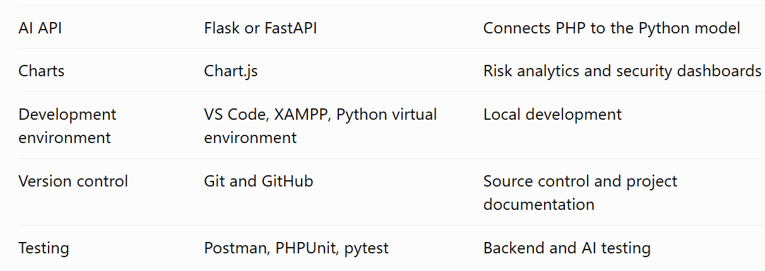
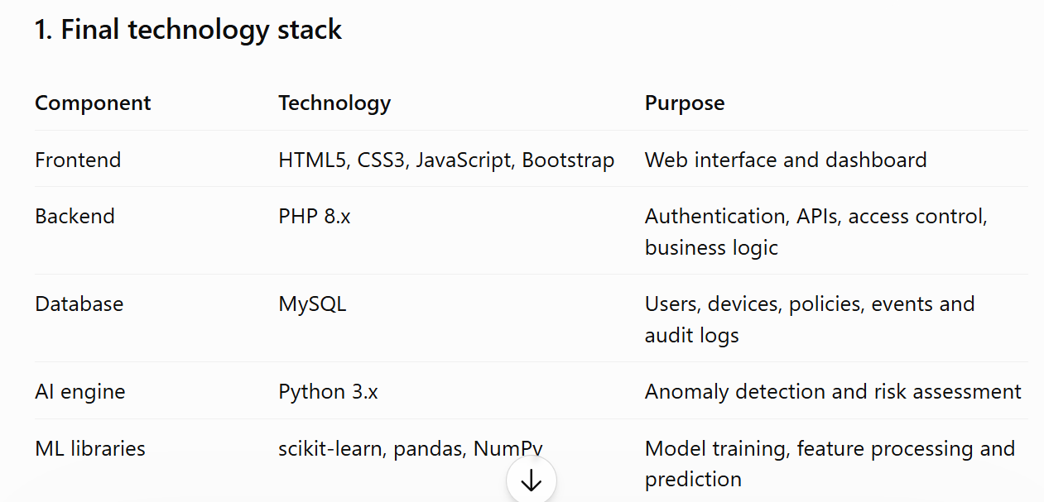

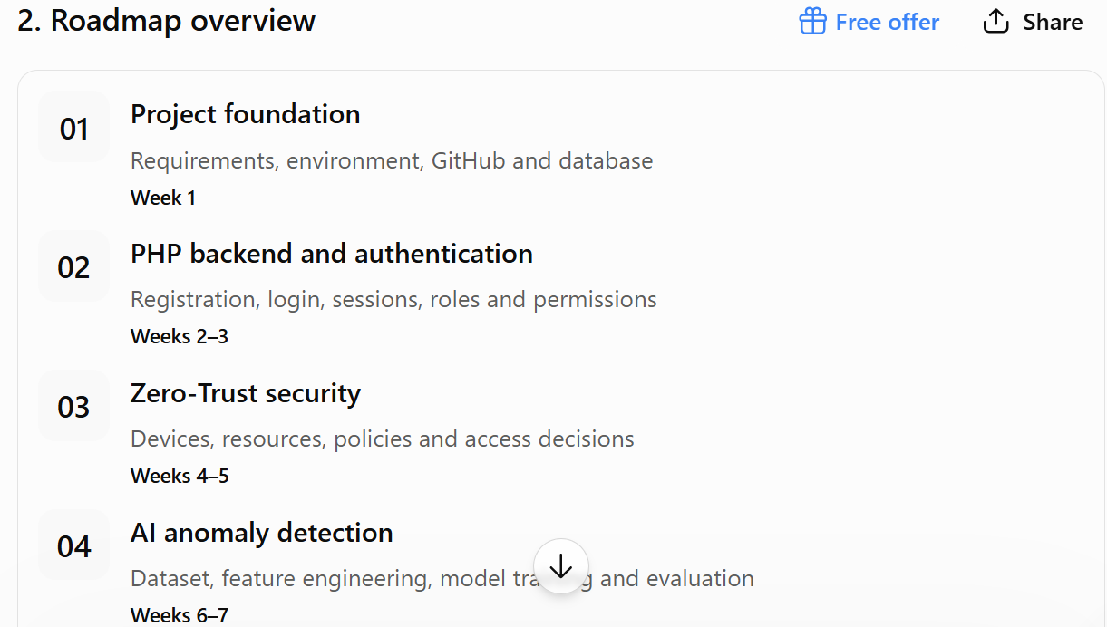
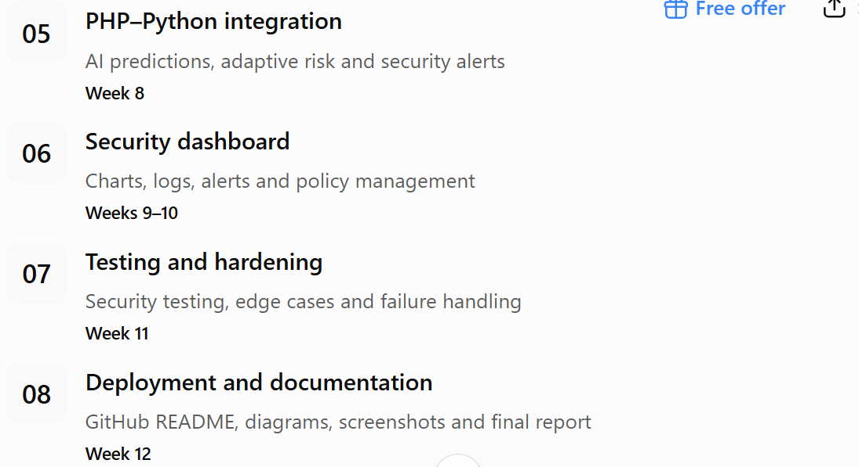
Project Outcome:
Imagine a university, bank, or company with hundreds of users. Someone logs in and tries to access a protected resource. Your platform should check:
- Who is the user?
- Has the user authenticated properly?
- Is the device recognized and trusted?
- Is the requested resource sensitive?
- Does the request look unusual compared with normal behavior?
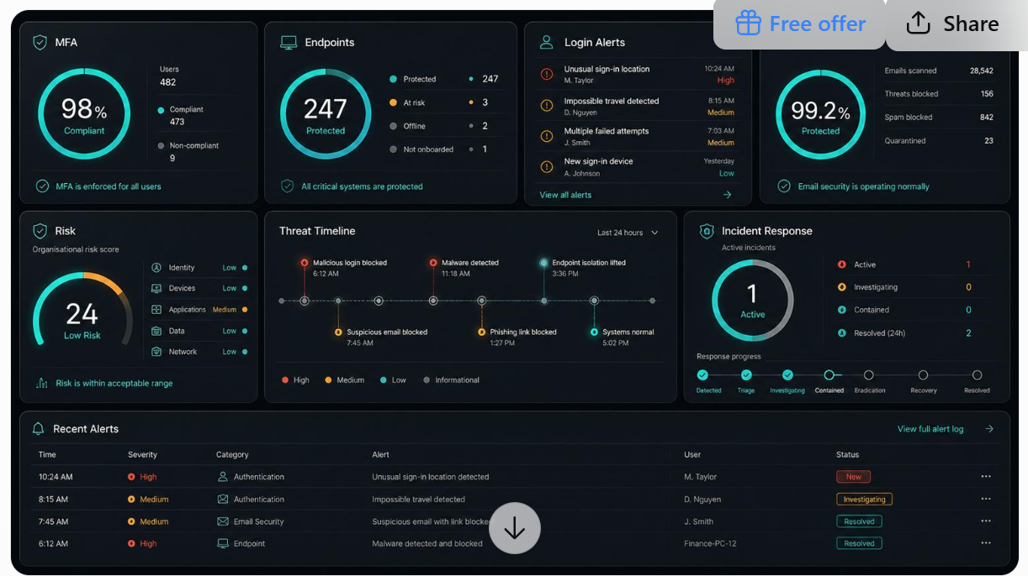
- Should access be allowed, challenged with additional authentication, or denied?

